Gallium in Solar Cells
While gallium has been used for many years as a constituent of the compound semiconductors found in LEDs and certain other electronic devices, it is also used in solar cells. Traditional solar cells have mostly been made using silicon but, in the move to improve efficiencies, there has been a lot of work to develop alternative thin film approaches. One particular material that has generated a lot of interest in recent years is known as CIGS, which stands for copper indium gallium selenide. The fact that CIGS contains gallium makes it of interest for the ReGaIL project as another potential end-of-life source of the valuable metal. This short article gives a brief introduction to solar cells and why CIGS is of growing interest in such applications.
In simple terms, a solar cell is a device that can convert light into electricity, and it does this using the photovoltaic effect, a process that was discovered by Becquerel in 1839. The first practical solar cell was demonstrated by Bell Laboratories in 1954 and since then there has been growing interest and application of these devices. In more recent times, solar cells have become increasingly popular as an alternative to the traditional methods of generating electricity. This has been made possible by improvements in their efficiency and because of reductions in production costs. Although many materials can be used to make solar cells, silicon is by far the most popular material. It can be used in a variety of forms with what is known as solar grade silicon being the most prevalent. These different types of silicon have been developed for two main reasons: improved efficiency and reduced costs. Additionally, there has also been a lot of work on completely different materials such as cadmium telluride, gallium arsenide and copper indium gallium selenide (CIGS) thin films. The latter two materials both contain gallium and could thus be valuable sources of the metal at end of life, if they are widely adopted.
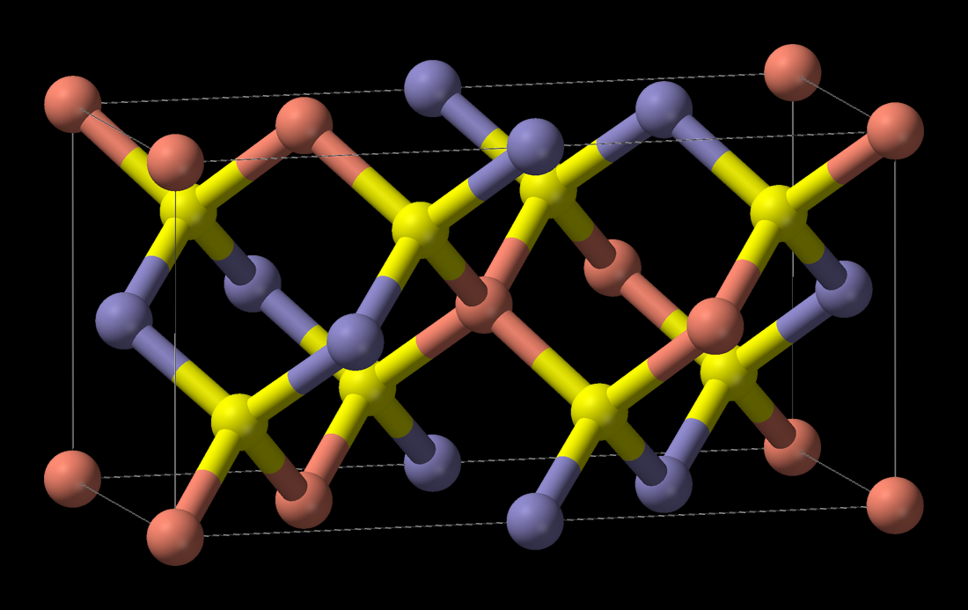
The structure of CIGS (Red = Cu, Yellow = Se, Blue = In/Ga
Copper indium gallium selenide has attracted attention because it offers the highest efficiency among all of the candidates considered for making thin films solar cells. It has a very high absorption coefficient and cells with efficiencies of over 22% have now been produced. Also, there are predictions that efficiencies of over 30% may eventually be possible. In fact, it has been estimated that a CIGS solar panel will produce between 10% and 20% more electricity than a crystalline silicon cell under the same typical operating conditions. Another key benefit of CIGS is that it takes significantly less energy to produce a solar panel than a crystalline silicon equivalent, thus offering a much-reduced carbon footprint that is getting closer to that of wind power.
CIGS can be made by using conventional techniques such as evaporation and sputtering and these offer the possibility of deposition onto low-cost flexible substrates, as well as glass etc. There are various other materials needed to make a working device, such as molybdenum, which is used as a back contact because of its high reflectivity. The structure of a CIGS solar cell involves the deposition of multiple thin film layers and a cross section schematic is shown below.
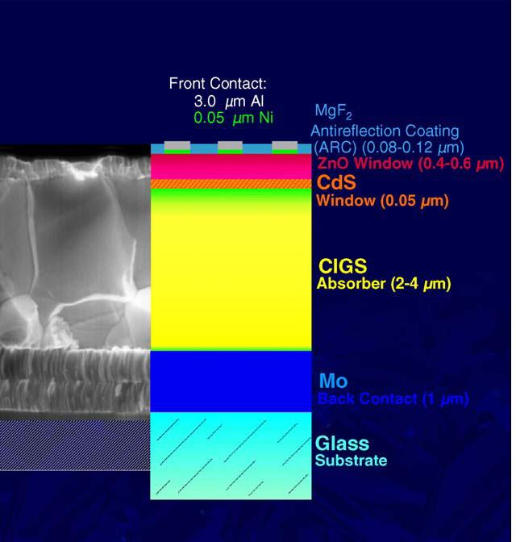
Section through a CIGS solar cell
(Kazmerski, L. - National Renewable Energy Laboratory, Public Domain, https://commons.wikimedia.org/w/index.php?curid=6669206)
In terms of the actual gallium content found in CIGS, it is important to understand that this can vary, as indicated by the generic formula for the material shown below.
Cu(In_{x}Ga_{1-x})Se₂
Before CIGS was identified as the preferred material, the originally investigated compound was copper indium selenide, i.e. there was no gallium present. However, it was subsequently found that, by replacing some of the indium with gallium, it was possible to further improve the efficiency and provide a more optimal bandgap. From a recycling and recovery perspective, the actual ratio of indium to gallium is not that critical, as both are valuable and considered to be critical raw materials. More importantly, China is responsible for a significant proportion of the global production of both metals and thus securing local supplies may also be strategically important for the UK and other countries.
At the moment most solar cells are made of silicon but if materials such as CIGS do become a popular alternative, there will be a significant demand for both indium and gallium. Likewise, there will then be large quantities of these metals available for recycling at end of life. Even though they are used in thin film form, the levels of indium and gallium present are still likely to be higher than those found in their ores. For example, it has been reported that gallium and indium concentrations of around 600 and 90 ppm, respectively, are typically present in CIGS solar panels. Also, considering that the materials of interest are there as thin films and will cover very large surface areas, it seems likely that they will be amenable to relatively straightforward standard etching techniques.
In summary, the use of solar electricity generation is set to increase significantly in the coming years as the world continues its move to renewable energy. One way of enabling this transition is via the use of high efficiency thin film solar cells that can be produced at lower cost. There are a number of candidate materials and copper indium gallium selenide (CIGS) is continuing to receive a lot of attention. While it is by no means certain exactly what proportion of solar cells will be based on thin film CIGS, it is important to recognise that such cells will contain gallium, indium, and other valuable materials that can be recycled and reused when panels reach end of life. Recycling and end-of-life issues are becoming increasingly important in the context of solar panels as the volume of installed units continues to grow. CIGS offers the possibility of low impact and high value recycling processes for key raw materials. Implementing environmentally benign circular economy approaches to solar panels will be a critical part of ensuring the global benefits of switching to renewable energy generation are fully realised.

Martin Goosey
March 2021

