**Continuous Professional Development**

**Certificate of attendance**

Subject: **Foundation Course**

**Unit 6 Surface Finishing WEBINAR**

Date: 19th September 2023

Host: John Burgess FIMF

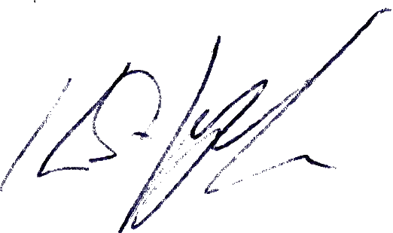

Witness: (President)

_______________