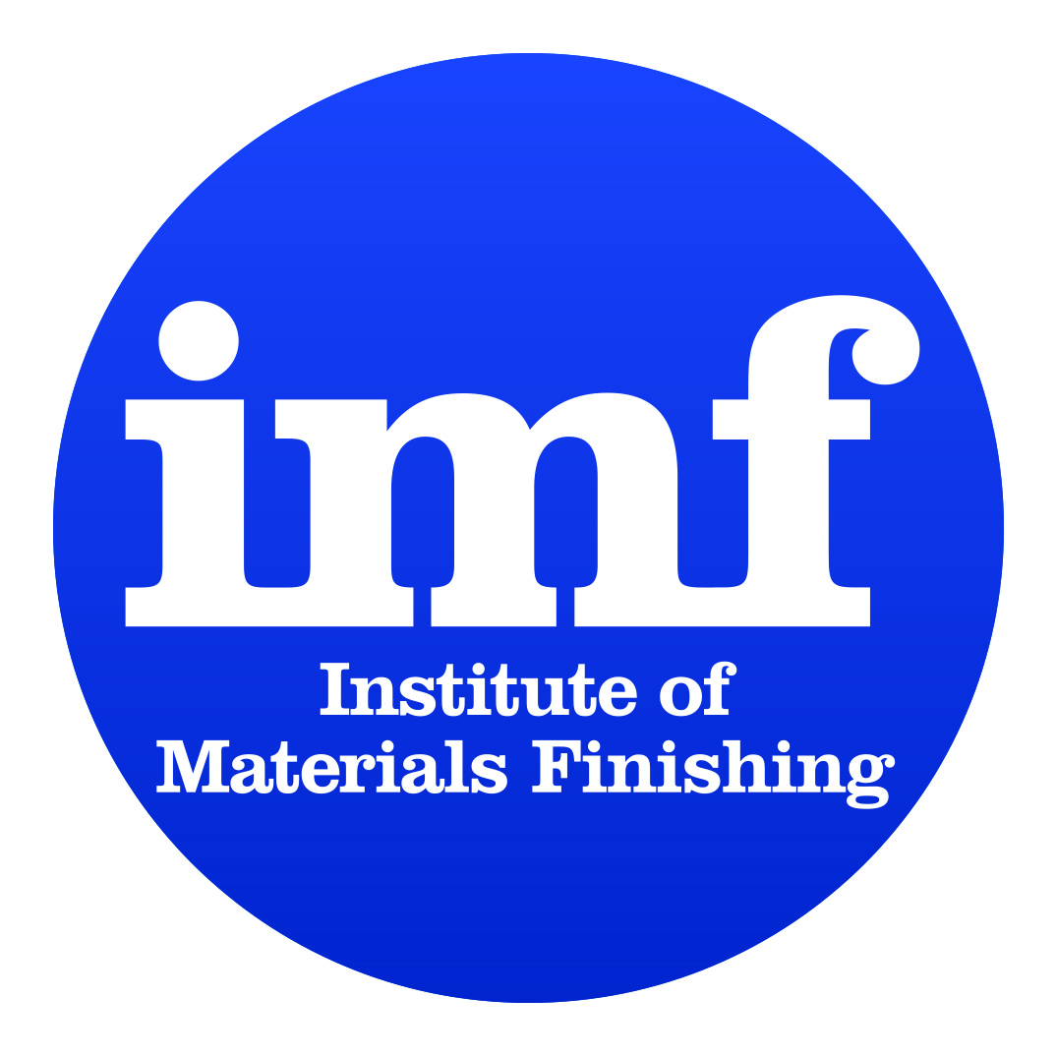

AGENDA
Institute of Materials Finishing AGM 2022-23
29th November 2023
Windmill Village Hotel – Coventry

10:30 Registration - Coffee and biscuits

10:45 Call to take seats for the start of the AGM.

10:55 KR as Chairman of the AGM introduces PL as MC for AGM
- PL explains fire regulations and sets out the format for the morning

11:00 Presentations:

Anti Corrosive Primers for Aluminium Alloys

Dr Violaine Medez
Indestructible Paint

AND

Routes to Carbon Reduction and Energy Saving

Bryan Glendinning – CEO Engenera Renewables Group
Martin Kenzie – Sales Manager 2-G Energy Ltd
Gaige Ross – Sales Director Smart Ease Finance
Gerry Nicell – National sales Manager Engenera Renewables Ltd

12.15 Awards

12:30 PL announces closure of morning session and lunch

12.40 Lunch – In Loft 18 Restaurant

14.15 KR requests Members to take their seats for the afternoon session.

1) KR calls for approval of the minutes of the AGM held 8th December 2022

2) KR introduces the President’s Report for the year 2022/23

3) GA introduces the Report of Management Board for the year 2022/23

4) JO introduces the Statement of Accounts for the year 2022/23

5) KR calls for the Ratification of the New President for the 3-year period 2024-2026

6) KR calls for the Ratification of the Secretary General and Treasurer for 2023/2024

7) GA announces the names of Officers, Management Board Representatives,
Standing Committee, Branch and Group Chairmen to serve for the 2023/24 Institute year.

8) GA calls a discussion about the Auditor.

8) AOB
Meeting closes

