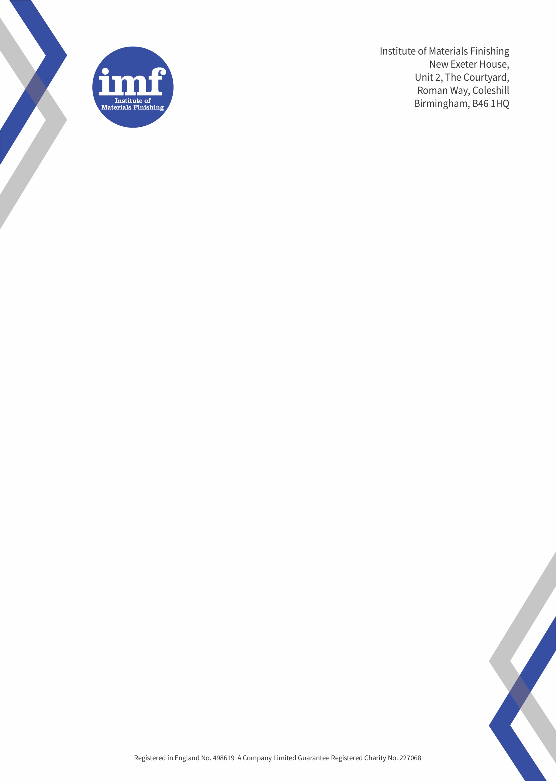

Continuous Professional Development

Certificate of attendance

Subject: Sacrificial Coatings

Date: 26th November 2024

Host: John Burgess FIMF


Witness: President
David Neal

